Name – Gayatri Dnyaneshwar Avhad

Roll no- 231071007

Batch – A

Assignment -3

1

AIM: To understand the process of finding SPI and CPI using rule book of UG

program and to solve given problem by write ng algorithm for it .

THEORY:

→ SPI (Semester Performance Index):

The Semester Performance Index (SPI) is a quan ta ve measure of a student's

academic performance within a specific semester. It reflects the weighted

average of grade points earned in all courses registered during that period. A

higher SPI indicates superior academic achievement. Formula: SPI = (c1g1 +

c2g2 + c3g3 + ... + cn\*gn) / (c1 + c2 + c3 + ... + cn) Where: \* c1, c2, c3, ... cn are

the credits of individual courses. \* g1, g2, g3, ... gn are the grade points earned

in corresponding courses.

→ CPI (Cumula ve Performance Index):

The Cumula ve Performance Index (CPI) provides a comprehensive evalua on

of a student's academic performance from the me of admission un l the end

of a par cular semester. It is calculated similarly to SPI but encompasses all

courses registered towards the degree requirements. A higher CPI denotes

be er overall academic standing. Formula: CPI = (Σ(Ci \* Gi)) / (ΣCi) Where: Σ(Ci

\* Gi) is the sum of the product of credits (Ci) and grade points (Gi) for all

courses taken ll the current semester. ΣCi is the sum of the total credits of all

courses taken ll the current semester.

→ Key Points:

● Both SPI and CPI are calculated based on the credit-weighted average of

grade points.

● A higher SPI or CPI generally correlates with be er academic performance.

● SPI reflects performance in a single semester, while CPI provides a

cumula ve overview.

● These indices are crucial for academic evalua on, scholarship eligibility, and

placement opportuni es.

ALGORITHM:

1)SPI AND CPI USING CREDITS AND GRADEPOINTS :

1. Start

2. Ini alize:

- spi as an empty list/vector to store SPI values for each semester.

- n as the number of semesters.

- spisum to accumulate the sum of SPI values for calcula ng CPI.

3. Input:

- Prompt user to enter the number of semesters n.

4. For Each Semester (from 1 to n):

- Call Func on getspi(sem):

- Ini alize:

- product to 0 (to store the weighted sum of grade points).

- creditsum to 0 (to store the total credits).

- Input:

- Prompt user to enter the number of subjects m for the current semester.

- For Each Subject (from 1 to m):

- Prompt user to enter the credits for the subject.

- Prompt user to enter the grade point for the subject.

- Calculate the contribu on of the subject as currcredit,currgradept.

- Add this contribu on to product.

- Add currcredit to creditsum.

- Calculate:

- SPI for the semester as product / (float)creditsum.

- Return SPI value to the calling func on.

- Store the returned SPI value in spi list/vector.

- Print the SPI for the current semester.

5. Calculate CPI:

- Ini alize:

- spisum to 0.

- Sum:

- For each SPI value in spi, add it to spisum.

- Calculate:

- CPI as spisum / (float)n.

6. Output:

- Print the CPI value.

7. End.

2)CPI USING SPI :

1. Start

2. Input Number of Semesters

- Prompt the user to enter the number of semesters, `n`.

- Read the value of `n`.

3. Ini alize Array for SPI

- Create an array (or list) `spi` of size `n` to hold the SPI values for each

semester.

4. Input SPI Values - For each semester from 1 to `n`: - Prompt the user to enter the SPI value for the current semester. - Read the SPI value and store it in the `spi` array at the current index.

5. Calculate CPI - Ini alize a variable `spisum` to 0. - For each SPI value in the `spi` array: - Add the SPI value to `spisum`. - Compute the CPI as `spisum / n`.

6. Output CPI - Print the calculated CPI value.

7. End

SCREENSHOT:

1. SPI AND CPI CALCULATION USING CREDITS AND GRADEPOINTS :

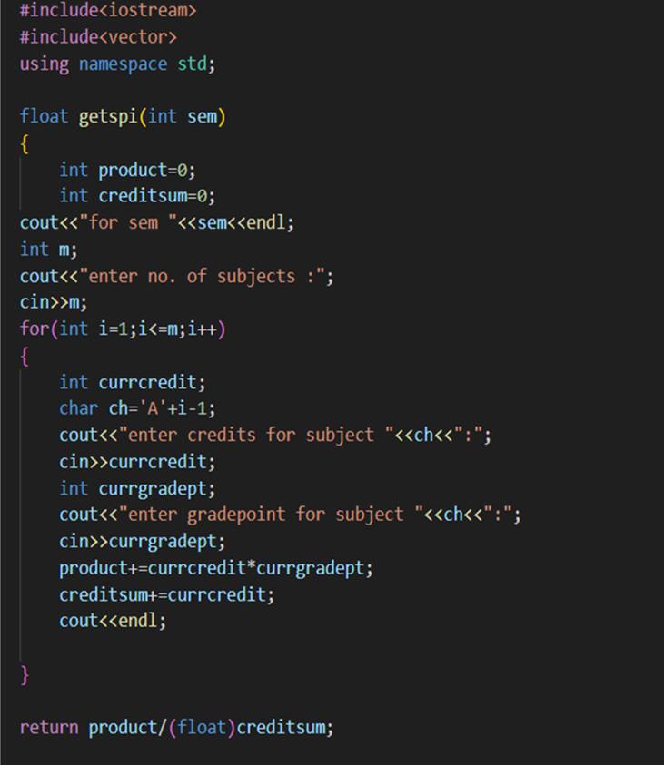

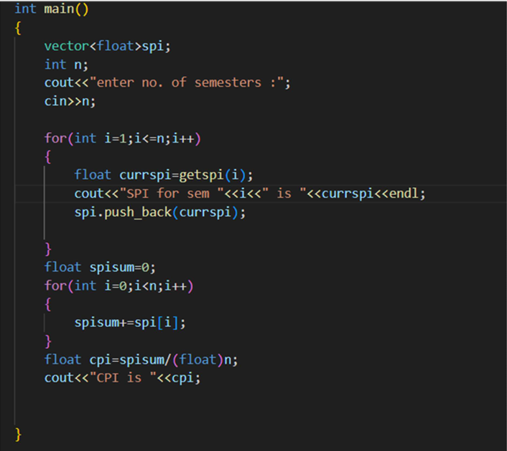

OUTPUT :

1)

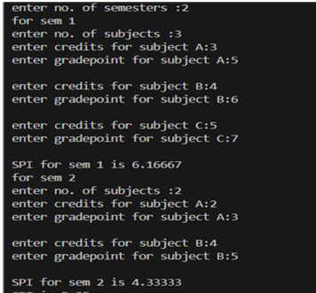

2)

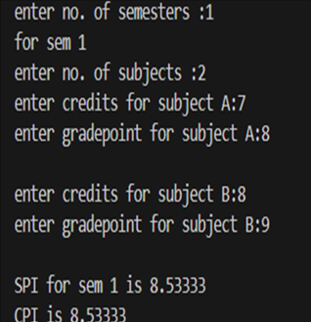

3)

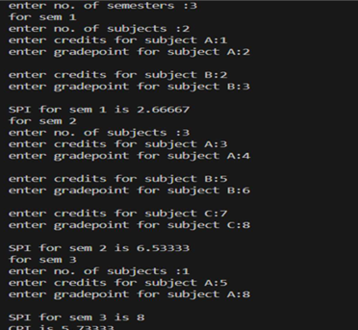

4)

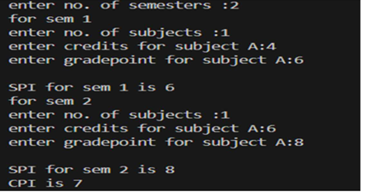

5)

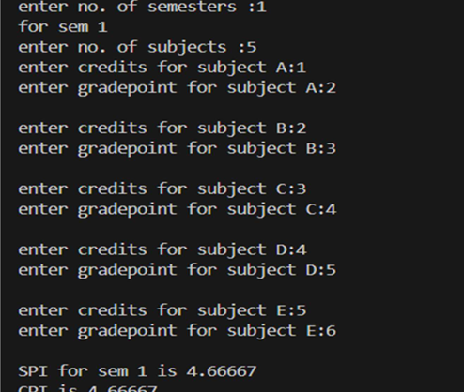

2)CPI USING SPI : 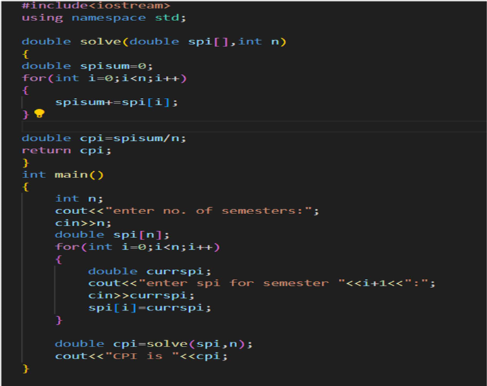

1)

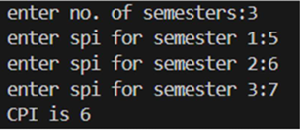

2)

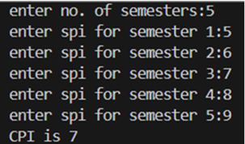

3)

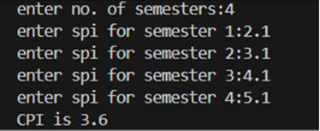

4)

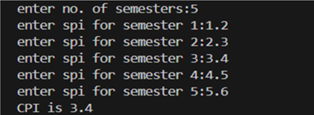

5)

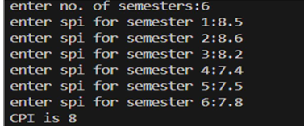

Conclusion:

In this way, we understood how to calculate SPI,CPI and also CPI using SPI

effectively by writing algorithm and implementing algorithm program.